Name: Joe Merrill
Date: 3 FEB 2026
Week: 4 - Create a Design Model for a Small Bed & Breakfast Reservation System
1) Rubric Criteria: Create software system architecture diagram 10%
Your Response:
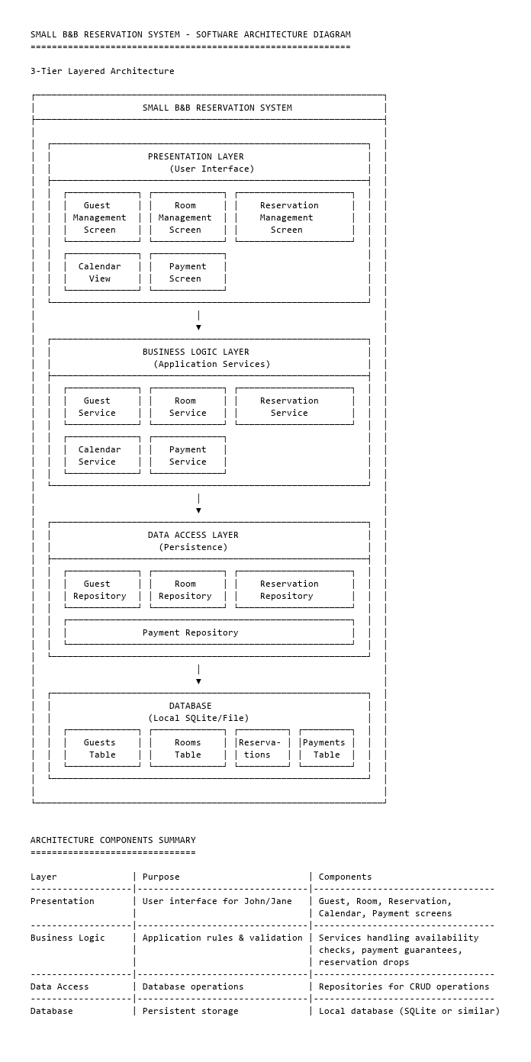
2) Rubric Criteria: Explain approach, steps, and rationale of the software architecture diagram 20%
Your Response:
The design approach followed a requirements driven methodology, analyzing the business needs of John and Jane's B&B to select an architecture that matches the system's scale, complexity, and usage patterns.

Steps Taken
1. Analyze System Requirements
-Small scale, single location business
- 2 users (John and Jane) - no guest self-service
-Core functions: manage guests, rooms, reservations, and payments
-Need for persistent data storage
-No requirement for web access or distributed computing

2. Evaluate Architecture Pattern
-3 tier layered pattern
-Positives: Separation of concerns, maintainable
-Negatives: Slightly more complex

3. Define Layers
-Mapped each requirement to the appropriate layer
-Ensured single responsibility principle on each layer

Step 4: Identify Components Within Each Layer
-Derived components directly from the analysis class diagram (Guest, Room, Reservation, Payment, Calendar)

3) Rubric Criteria: Create detailed UML class diagram 15%
Your Response:
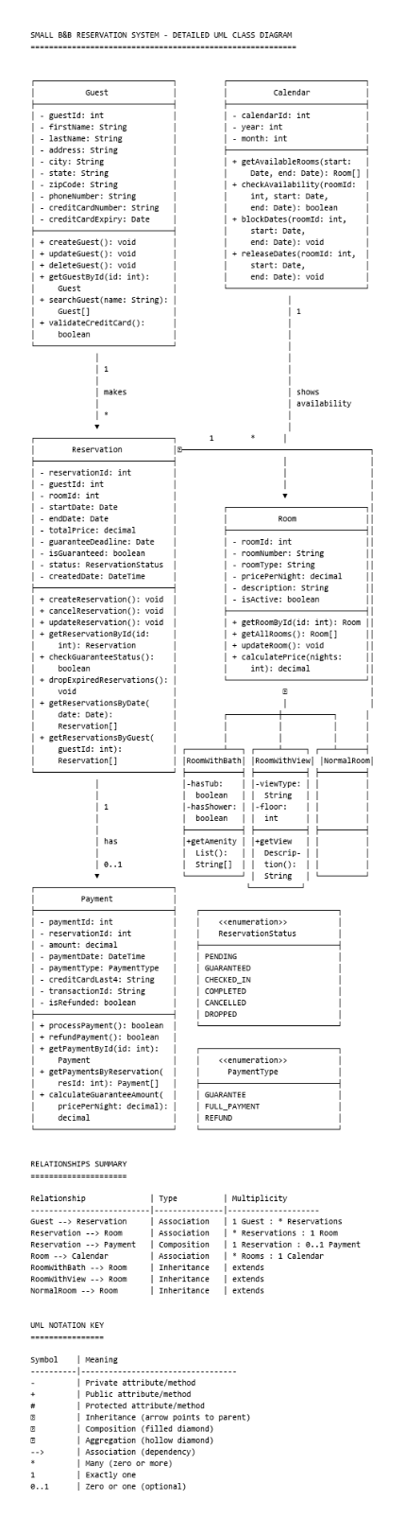

4) Rubric Criteria: Explain approach, steps, and rationale of the detailed class diagram model 25%
Your Response:
The class diagram was developed by refining the analysis class diagram. Each class was expanded with specific attributes and operations needed to fulfill the use cases.

1. Identify Attributes from Requirements
Requirement | Attributes
Enter customer's name, address, phone number | Guest: firstName, lastName, address, city, state, zipCode, phoneNumber
Credit card number | Guest: creditCardNumber, creditCardExpiry
Reservation dates | Reservation: startDate, endDate
Room price | Room: pricePerNight; Reservation: totalPrice
Guaranteed by 1 day's payment | Reservation: isGuaranteed, guaranteeDeadline
Room with private bath, lake view, normal | Room subclasses with specific attributes
Reservations will be dropped | Reservation: status (enum with DROPPED state)

2. Assign Methods Based on Use Cases
Use Case | Methods Assigned
Maintain Guest Records | Guest: createGuest(), updateGuest(), deleteGuest(), getGuestById(), searchGuest()
Maintain Room Records | Room: getRoomById(), getAllRooms(), updateRoom(), calculatePrice()
Make Room Reservation | Reservation: createReservation(), updateReservation(); Calendar: getAvailableRooms(), checkAvailability(), blockDates()
Drop Room Reservation | Reservation: cancelReservation(), dropExpiredReservations(), checkGuaranteeStatus(); Calendar: releaseDates()
Manage Payment | Payment: processPayment(), refundPayment(), calculateGuaranteeAmount()

3. Define Relationships and Multiplicities
Relationship | Analysis | Design
Guest ↔ Reservation | A guest can have multiple reservations over time | 1 Guest : * Reservations
Reservation ↔ Room | Each reservation is for exactly one room | * Reservations : 1 Room
Reservation ↔ Payment | A guaranteed reservation has one payment; unguaranteed has none | 1 Reservation : 0..1 Payment
Room ↔ Calendar | All rooms share one calendar for availability | * Rooms : 1 Calendar

4. Apply Inheritance for Room Types
From requirements: "one room with private bath... room with lake view... two normal rooms"
Room (Abstract Parent)
LRoomWithBath (hasTub, hasShower, getAmenityList())
LRoomWithView (viewType, floor, getViewDescription())
LNormalRoom (no additional attributes)

5) Rubric Criteria: Create user interface mockup 10%
Your Response:
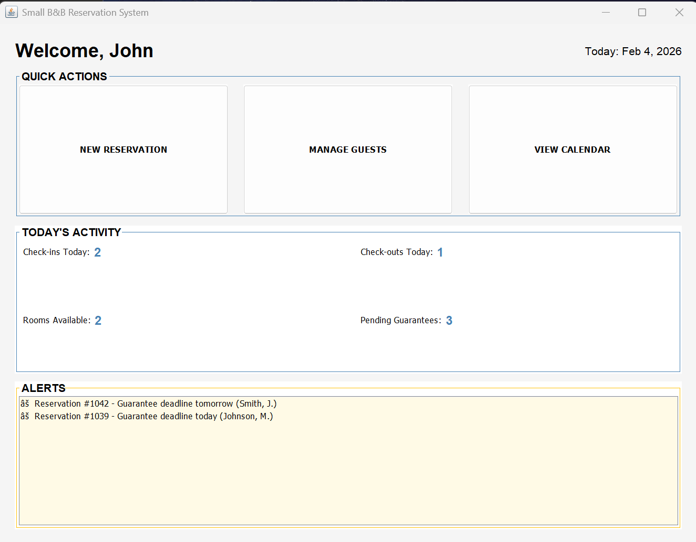

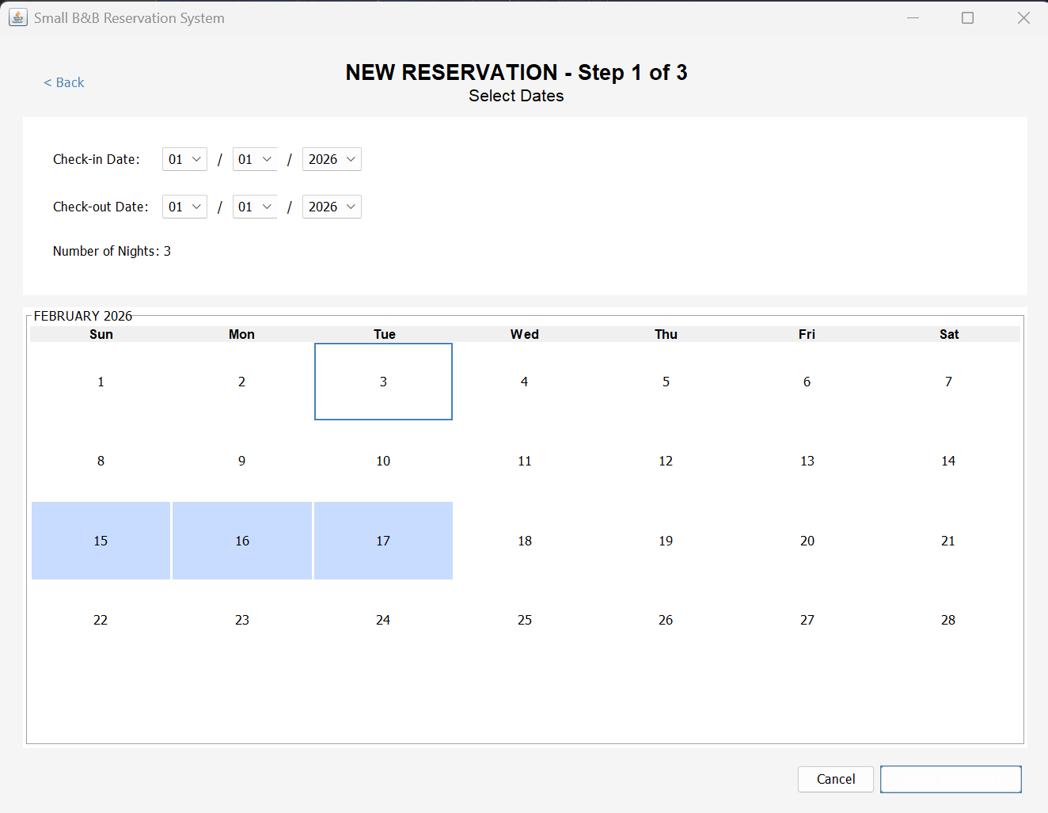
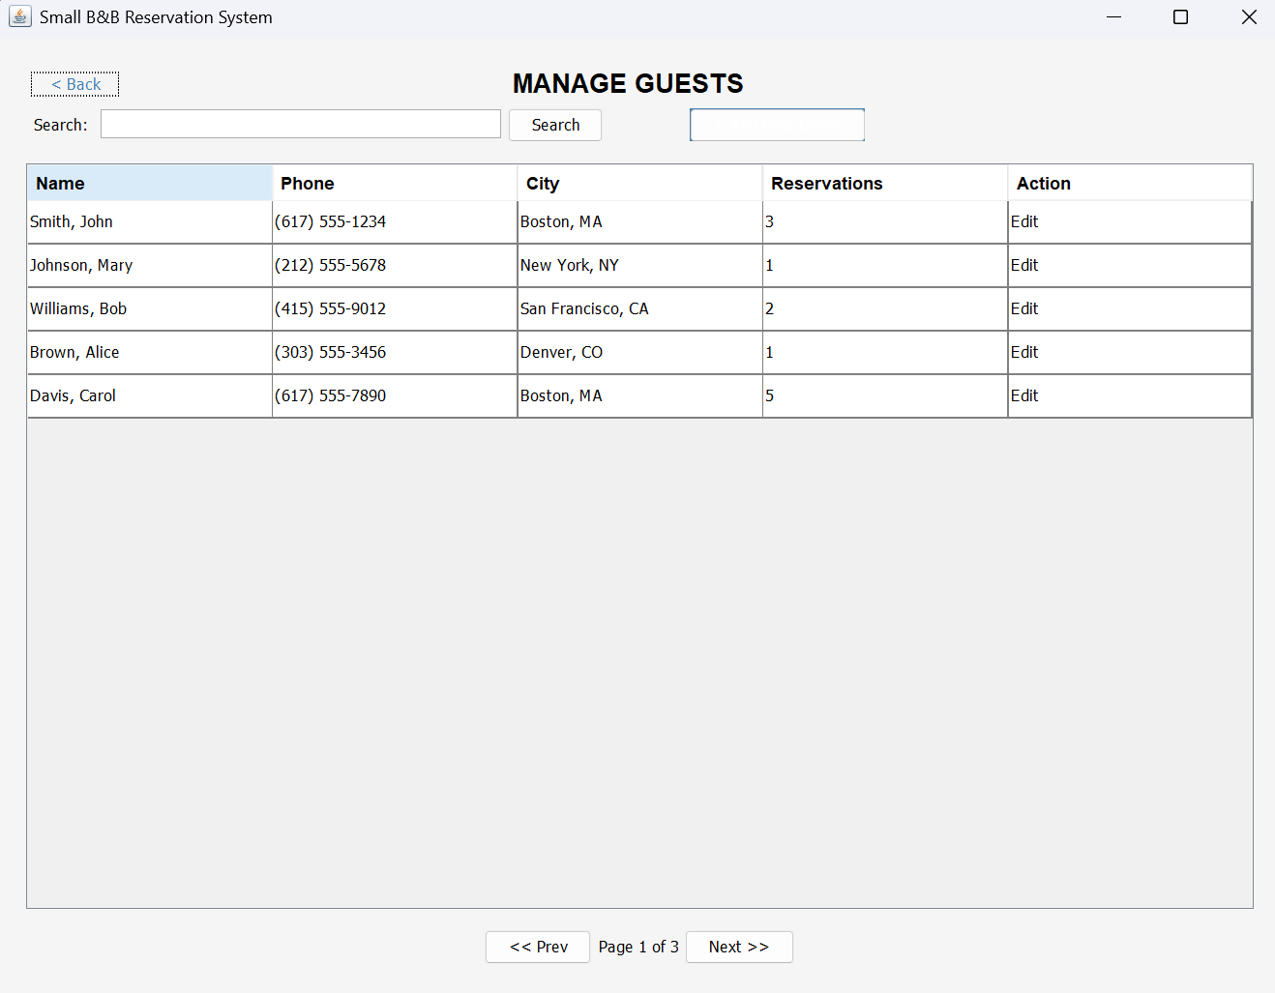
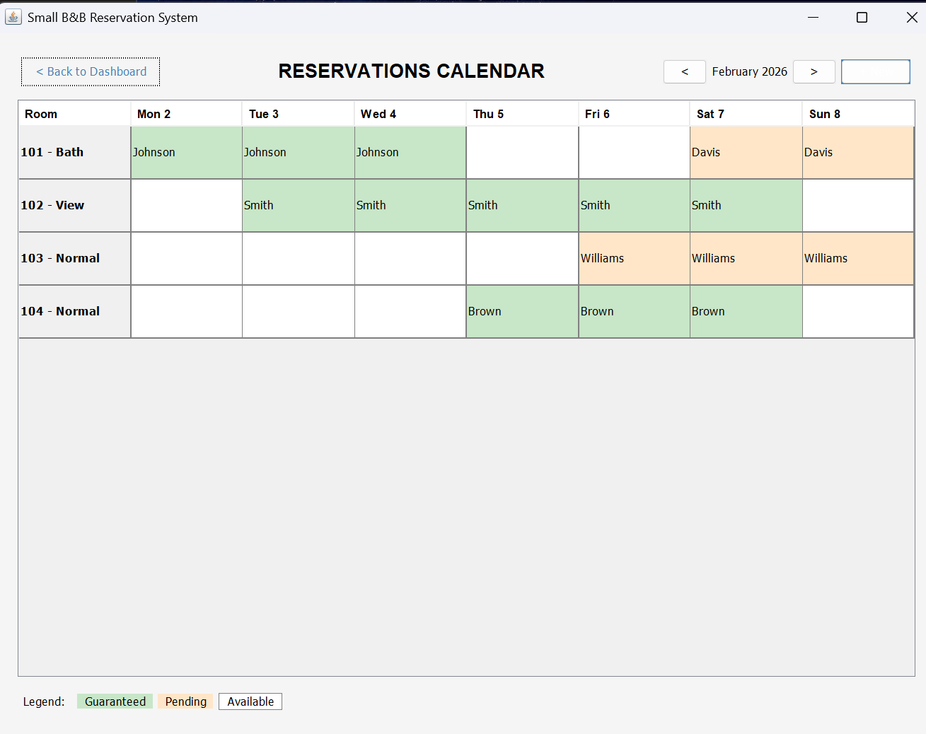

6) Rubric Criteria: Explain approach, steps, and rationale of the user interface mockup 10%
Your Response:
The UI design followed a task centered design methodology It focuses on the primary users (John and Jane) and their main workflow: making reservations for guests who call by phone. The design prioritizes simplicity, efficiency, and error prevention.

Steps Taken
1. Identify User Tasks from Use Cases
Use Case | UI Screens Required
Make Room Reservation | Date Selection → Room Selection → Guest/Payment → Confirmation
Maintain Guest Records | Guest Management Screen
Maintain Room Records | Calendar View (shows room status)
Drop Room Reservation | Dashboard Alerts + Calendar View
Manage Payment | Integrated into Reservation Flow

2. Design the Navigation Flow
Dashboard (Home)
|--New Reservation (Wizard: 3 steps)
|---Step 1: Select Dates
|---Step 2: Select Room
|---Step 3: Guest Info & Payment
|----Confirmation
|--Manage Guests (CRUD operations)
|--Calendar View (Visual overview)

Step 3: Apply UI Design Principles
Principle | Implementation
Visibility | Dashboard shows today's activity and alerts at a glance
Feedback | Confirmation screen with checkmark; color-coded calendar
Constraints | Unavailable rooms are grayed out and unselectable
Consistency | Same button placement, colors, and navigation across screens
Affordance | Buttons look clickable; radio buttons for single selection

Step 4: Design Individual Screens
Screen | Design Decisions
Dashboard | Large action buttons for common tasks; alerts section highlights urgent items (pending guarantees)
Date Selection | Calendar widget for visual date picking; shows selected range highlighted
Room Selection | Card-based layout shows all room details at once; unavailable rooms visible but disabled
Guest/Payment | Two-column layout separates reservation summary from data entry; existing guest search saves time
Confirmation | Clear success indicator; all details visible; multiple next-action options
Manage Guests | Table format for quick scanning; search and pagination for scalability
Calendar View | Grid shows room availability across time; color coding for reservation status

User Interface Design Rationale
-Wizard-style reservation flow: Breaking the process into three steps (dates, room, guest/payment) reduces cognitive load and minimizes errors. John or Jane can focus on one task at a time while on the phone with guests, and the system validates input before allowing progression.

-Dashboard alerts section: This addresses the requirement that unguaranteed reservations must be tracked. Displaying pending guarantee deadlines prominently ensures John and Jane will not miss a deadline and lose a potential booking. Alerts are sorted by urgency with the most imminent deadlines first.

-Color-coded calendar view: Green indicates guaranteed reservations while orange indicates pending reservations needing guarantee payment. This visual distinction allows quick assessment of room availability and identification of bookings needing attention without clicking into details.

-Search existing guest feature: Returning customers are common in the B&B industry. Rather than re-entering all information for repeat visitors, searching by name and selecting an existing record speeds up the process and ensures data consistency.

-Guarantee now vs. later options: Radio buttons for these options directly implement the requirement that reservations can be held without immediate guarantee. When "guarantee later" is selected, the system prompts for a deadline date, accommodating guests who need to confirm travel plans first.

-Card-based room selection: Displaying room name, features, nightly rate, and total price in a single view supports the phone-based workflow. John or Jane can quickly relay all options to the guest without navigating between screens. Unavailable rooms are grayed out but visible, providing context while preventing booking errors.

-Back buttons on every screen: This allows users to correct mistakes without losing progress, which is important during phone conversations where guests might change their mind about dates or room preferences. The wizard preserves previously entered information during backward navigation

7) Rubric Criteria: Reflect on the learning experience and lessons learned 10%
Your Response:
-Importance of Traceability

Every design decision should trace back to a requirement. For example, the guaranteeDeadline attribute in the Reservation class directly implements the requirement that reservations will be held without guarantee for an agreed upon time.

-Layered Architecture Simplifies Complexity

3 tier architecture separates apprehensions. Changes to the UI don't affect business logic, database technology can be swapped without rewriting the application, and each layer can be tested independently. This was evident when designing the class diagram services in the business layer handle rules like "drop expired reservations," keeping that logic out of the UI.

-Design Models Bridge Analysis and Implementation

The analysis class diagram showed what entities exist. The design class diagram added how they work:

Data types for attributes
Method signatures
Visibility modifiers
Detailed relationships

This translation from analysis to design is where engineering decisions happen.

-UI Design Must Support User Workflows

Designing the UI forced me to think about how the users work. If the users are on the phone with guests they will need quick access to availability. To quickly track guarantee deadlines, dashboard alerts are an efficient feature. To quickly find returning guests, a search existing guest feature will help the users.

The UI isn't just about making things look nice, it's about optimizing task completion.

